For some time I have been looking for a way to utilize the FTDI TTL-232R USB to TTL Serial Cable. It is a simple way of solving the problem of having no serial ports on your laptop. It comes in a variety of terminations and in 5V and 3.3V versions:

http://www.ftdichip.com/Products/EvaluationKits/TTL-232R.htm

The datasheet is here:

http://www.ftdichip.com/Documents/DataSheets/Modules/DS_TTL232R.pdf

I am no design engineer, but from talking to several friends, reviewing various circuit diagrams of level converter circuits and a degree of try it and see I hit on the following circuit that works with every radio that I have tried: VX-6, VX-150, VX-170, VX-177, FT-60, FT-1802, FT-2800, FT-7800, FT-8800 and FT-8900.

Improvements to the circuit are welcome -

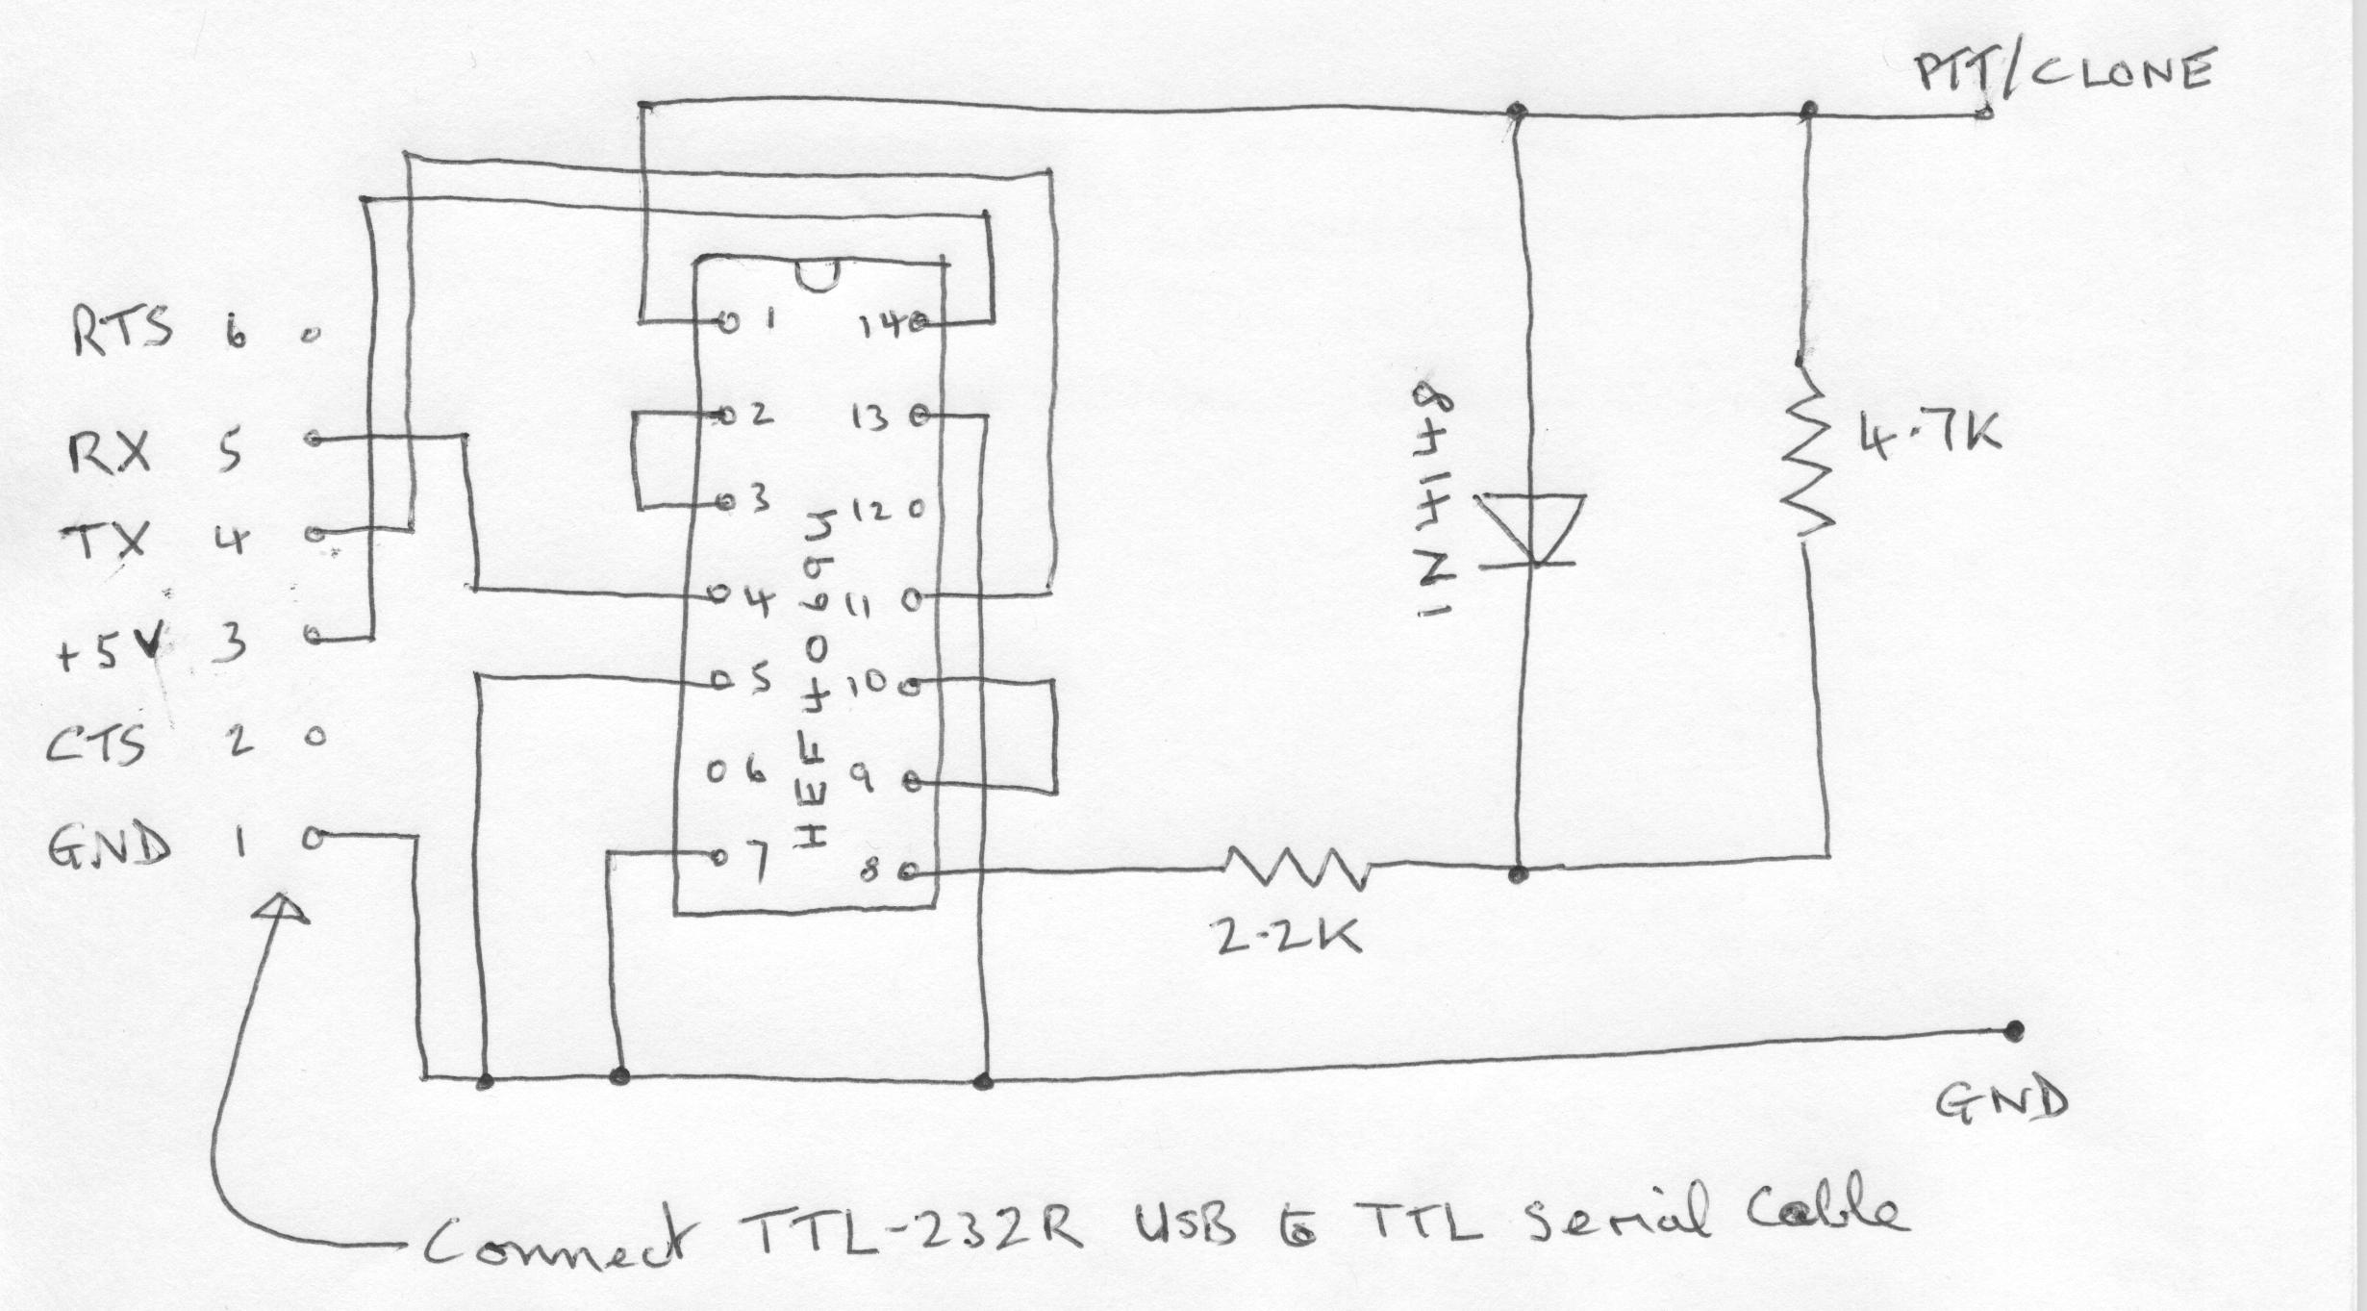

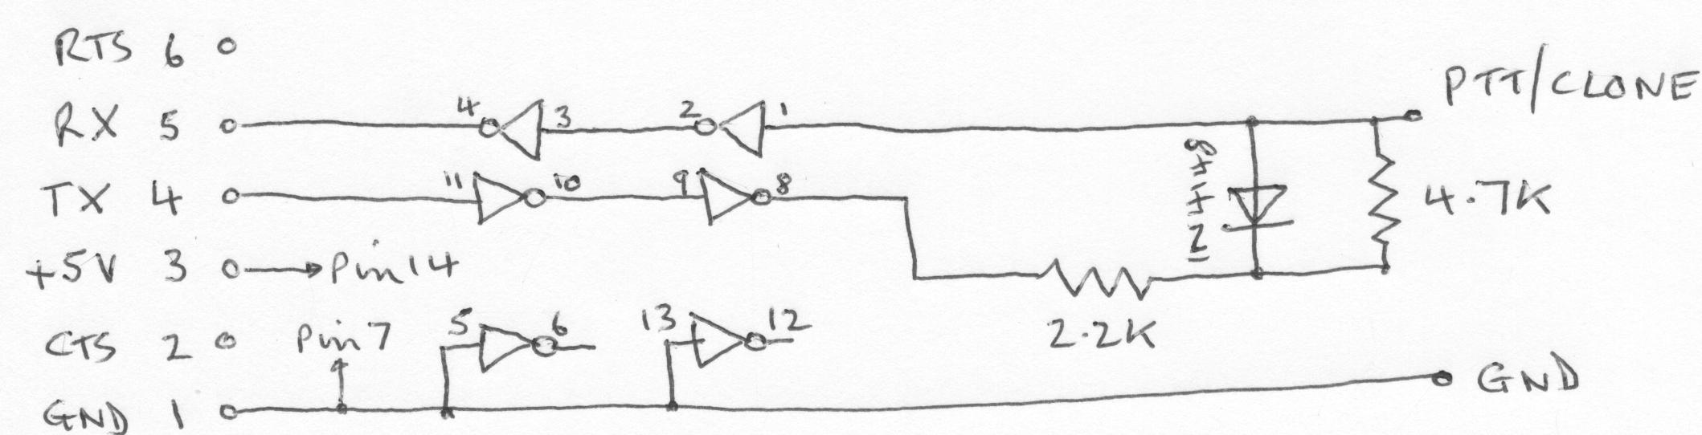

A picture of the prototype board:

